Experimental Report
Course name | Digital Image Processing
Student number | 2011561103 | Name | MD MUSTAFIZUR RAHMAN
Major | CST | Class | 20LC
Experiment Date | 22-10-17
Experimental content | Experiment 3 : Histogram Equalization
1．Purpose and tasks of the experiment

The main purpose and tasks of the experiment is to stored black and white grayscale image and display the image, display the histogram of grayscale, perform the histogram equalization processing on the image, display the processed image and histogram and finally draw the grayscale transformation curve and storing process of the image

2. Experimental steps and results

Describe the basic steps and main codes of the experiment and give the experimental results with pictures.
(Delete the red word when submitting the report)

Experiment steps and results are:
- Firstly, we set the grayscale of image. For showing the grayscale image the code is ImagGray = rgb2gray(Imag);
- Then we try to find the statistical grayscale histogram. For this we have to write this code GrayPixPro = GrayPixNum./(r*c);
- Count the number of occurrences of each pixel value. And the code is GrayAdd(1,i) = GrayAdd(1,i-1)+GrayPixPro(1,i);
- Normalize the grayscale histogram.
- Then we accumulation the histogram level.
- Calculate the pixel value of the new image after equalization using this code NewGrayPro(1,GrayTemp) = NewGrayPro(1,GrayTemp)+GrayPixPro(1,i);
- Multiply the corresponding element values. The code is plot(NewGrayPro.*(r*c)),title('equalization Histogram');
- Equalized the image with equalization histogram and mapping and the code is
NewImag = zeros(r,c);
for i =1:r
for j = 1:c
NewImag(i,j) = NewGray(1,ImagGray(i,j));
end
end
NewImag = uint8(NewImag);
figure()
imshow(NewImag),title('equalized image');
figure()
plot(NewGray),title('grayscale transformation curve');

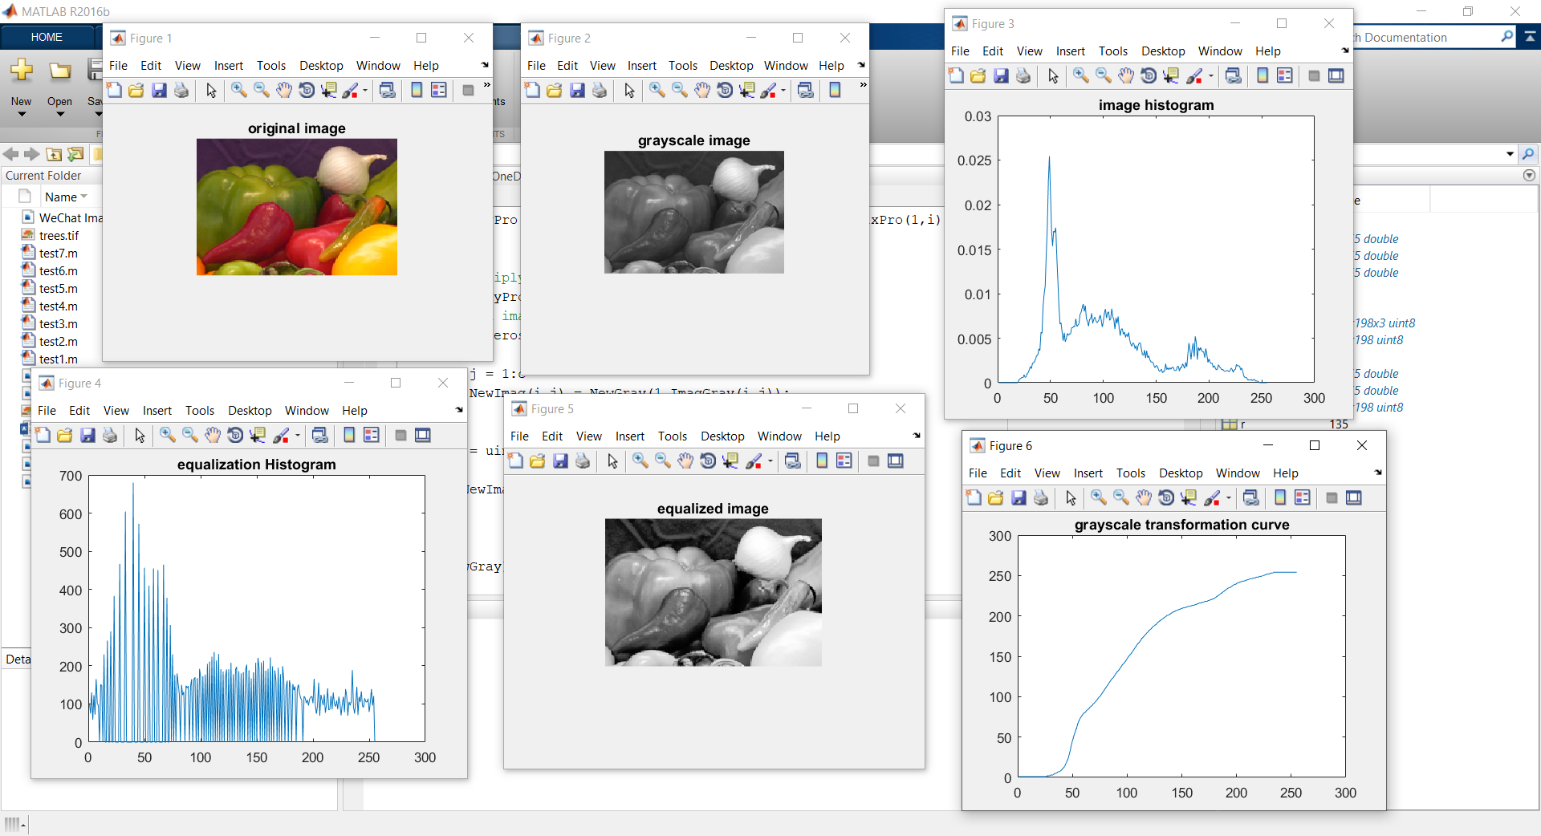

3. Answer the following question?
Please observe the experimental results. What are the changes and effects of the image after histogram equalization?

Answer: The changes and effects of the image after histogram equalization are from the image histogram, we can see that the level of image histogram’s initial level is high and then goes in low 0 to 250 level. And in the equalization histogram the graph is also same as the image histogram. Also, in the grayscale transformation curve level is also from 0 to more than 250.

4. Experimental experience

It means your feelings and your harvest
After doing this experiment I can really see the changes of different histogram of an image. And I like the changes. I enjoyed a lot doing this experiment and looking forward to do more experiment like this in the MATLAB.

